**Name _____________________**

**Date ______________**

***Dakota Opportunities in Education Foundation Scholarships***

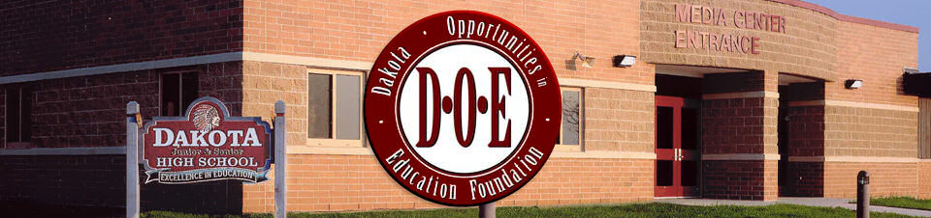

***Dakota Opportunities in Education Foundation Scholarships***

Trades Scholarship

Eligibility Dakota High School Senior planning to enroll full-time in a post-high school educational program in the fall following graduation Applicants must have a “C” average or better with a minimum of a 2.0 GPA.

Directions: Complete application and return to Kevin Cline by Thursday, March 27th, 2025. The applicant must include an official transcript and two letters of recommendations from a teacher or any person (not related to the applicants’ family) who knows the applicant well. Relationship to the applicant should be stated in the letter. All application materials must be written using MS Word or other electronic word processing. Incomplete applications will not be considered.

Activities: Include a separate sheet listing school activities, out-of-school activities, and work experience. Include any leadership positions held, honors, volunteering, and awards, etc.

Goals: Write a brief paragraph describing your educational plans and career goals.

Statement of Qualifications: Write an essay explaining why you should be considered for this scholarship.

Optional: Describe any personal or family circumstances which you feel should be brought to the attention of the selection committee.